**WEEK 02**

**Data Visualization**

***Best Practices to Visualize and Share the Design***

## Project mission

As a Data Analyst, we will often make exploratory data visualizations for us and other analysts to analyze data and solve problems together - much like our team did in Week 01. These visualizations are sometimes quickly thrown together, more informal, and may contain elements that only the team members who worked on it can understand.

In this week 02 task, we need to refine and simplify our data in such a way so that the marketing team and other outsiders understand it clearly. Also we have to come with an inference or conclusion which campaign we should drop and why.

## Steps Performed in This Project

### Data Cleaning

### Data Cleaning is the process in which we clean our data and remove the unwanted parts that may cause errors while analyzing it.

### We have already given our dataset so we don't need to discuss the further process here.

### Data Analysis

### After removing the errors from the data, now we need to analyze it. A number of tools like Power BI, Excel, Tableau, R, Python are used to clean, analyze and visualize the dataset.

However, we have used Power BI for the visualization of the dataset in order to reach an outcome. Power BI is no doubt a very helpful tool to work with Data.

### Data Visualization

### This is what we've done in our week 01- Visualization of the data. In this, we visualized our data to get proper insights that may help our marketing team to reduce the cost and use those funds for a better marketing approach.

### Communication/Presentation

### The final stage of our data analysis life cycle and also our week 02 task. In this task we need to present our data with the marketing team to help them in their marketing strategy.

### 

**Work**

When we started working with the data, we first decided which variables or data item we should pick so that we can be able to visualize and get the desired output.

We did some research and visualized the datasets. Here are the snapshots attached of the visualizations. We’ve also given a brief explanation of each graphs-

**Graph 1- Reach and Impression wrt Campaign Id:**

Campaign 3 and 11 with less reach and impressions as compared to other campaigns.

(Note: Blue color represents Sum of Impressions & Orange color represents Sum of Reach)

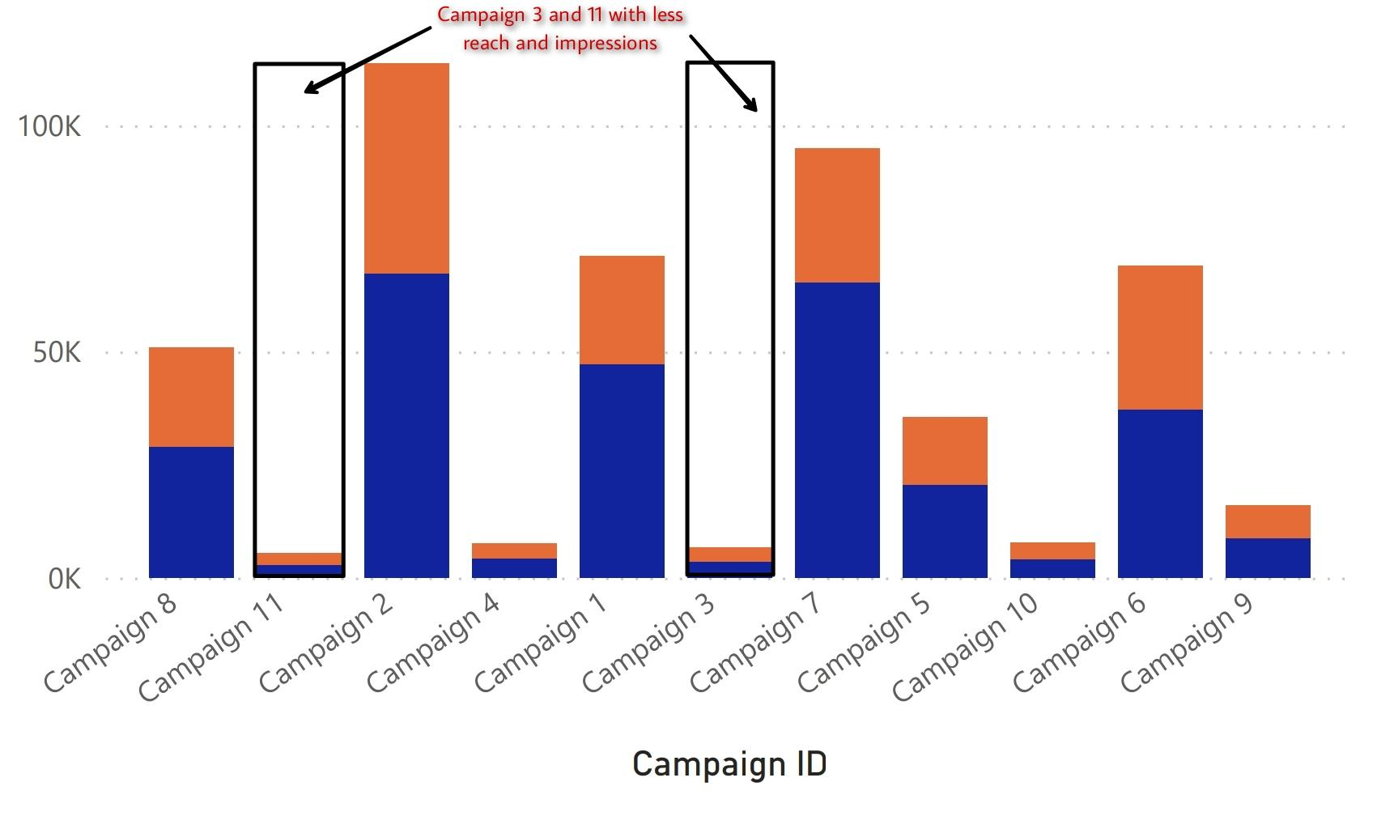

**Graph 2- Individuals campaign reach every age group**

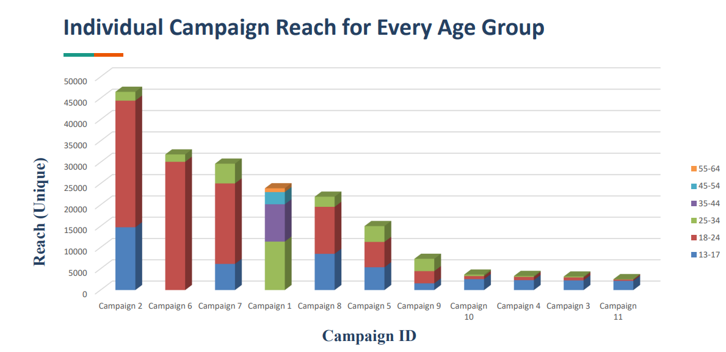

**Graph 3 - Amount spent for every camp location**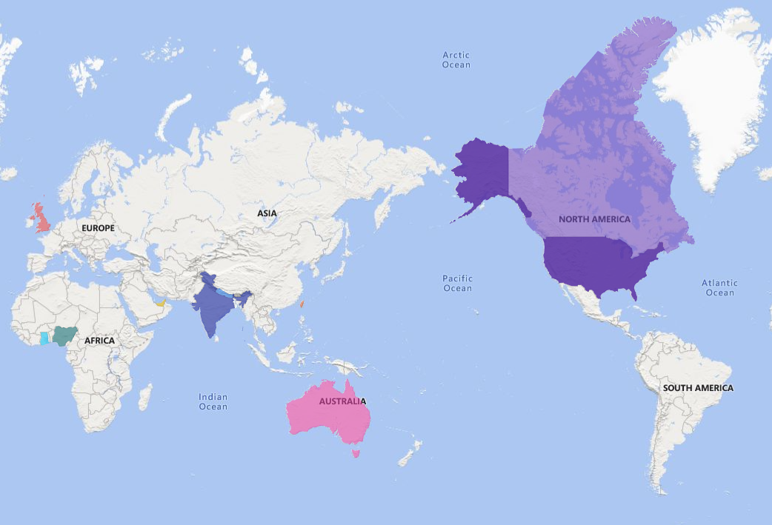

This is the map showing the amount spent for every camp location. Now let’s see the detailed data using the pie chart-

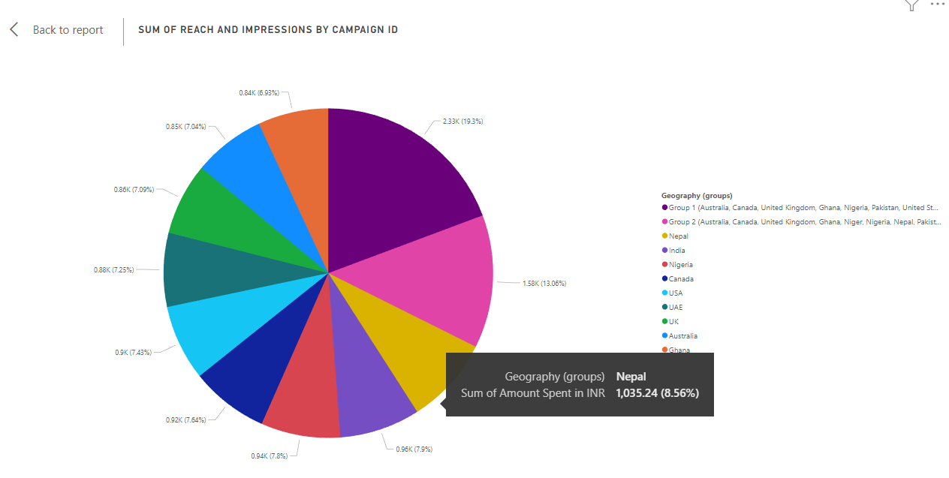

As we can see in the above pie chart, Nepal is the most expensive region (gross spend) having 8.56% of total amount spent as compared to other regions.

**Graph 4- Campaign Cost**

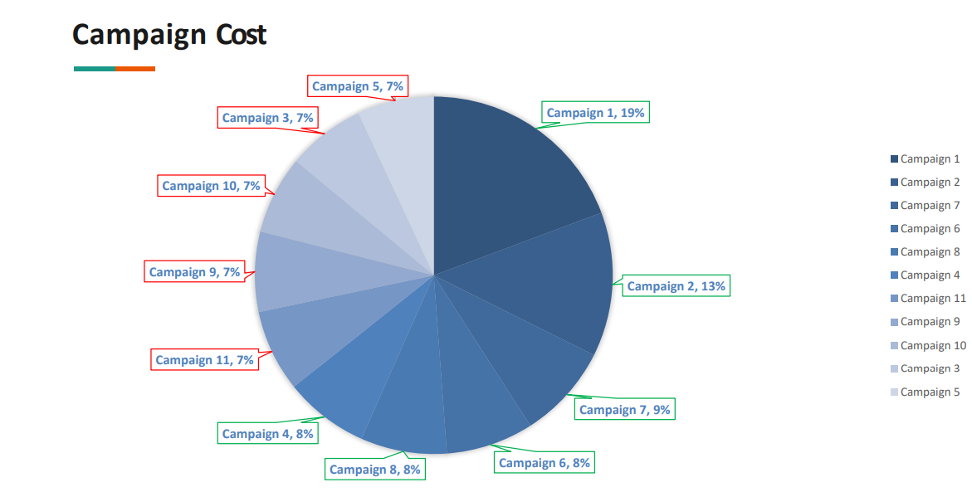

**Graph 5- CPR and ULC wrt Campaign Id**

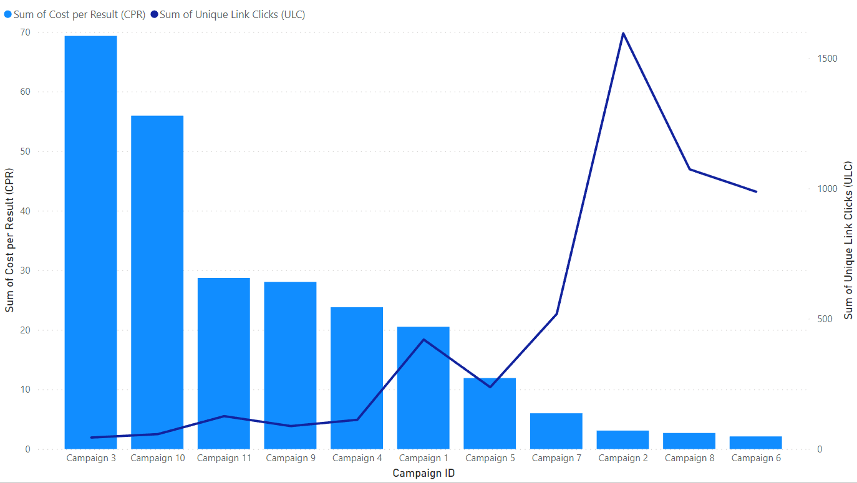

The chart above shows the comparison between cost per result of each ad campaign and the unique link-clicks of each campaign. The line chart represents the unique link-clicks (ULC), a metric used to measure the % of times people(unique) saw the ad and then clicked on the link. The bar chart represents the cost per result (CPR), a metric that measures the average cost per result.

From the chart we can conclude that campaign 3 has the highest CPR and the least ULC. Judging by the CPR AND ULC, we can conclusively state that campaigns 3, 4, 9, 10 and 11 are poor performers while campaigns 2, 6, 7, and 8 are good performers.

**Graph 6- Reach and Amount Spent**

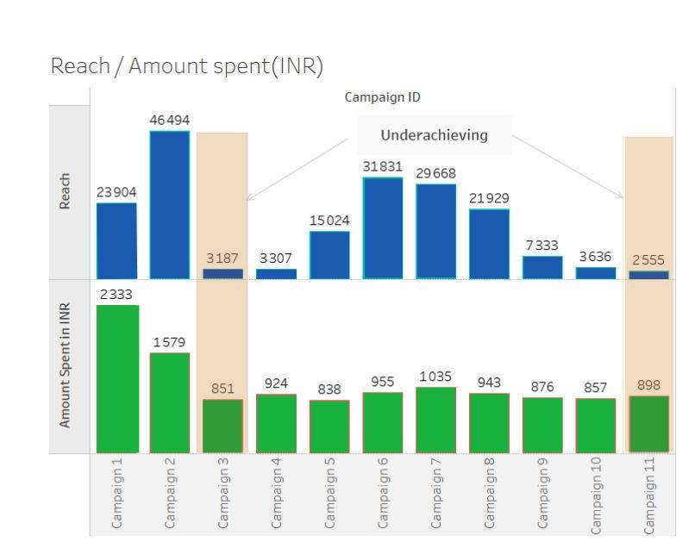

Comparing the Reach of each campaign to the total amount spent for each campaign, it can be seen that campaigns 3, 4, 10 and 11 have less reach and have their amount spent for campaigns within the same range. Campaigns 3 and 11 have the least reach overall and are the least cost effective.

**Graph 7-** CPC and CPR

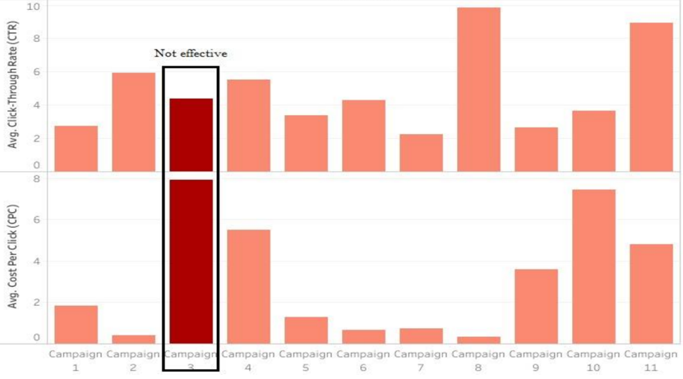

**Conclusion**

After visualizing and comparing the results, we came to a conclusion that Campaign 3 is having the lowest number of reaches and impressions, while also having a higher amount spent. Therefore, **Campaign 3** should drop due to their low result and cost efficiency.

# Meet the Team

***Sponsor Company***– Excelerate

***Individual Company Contacts***– Dhananjay Zende, Project Head

Team Lead represents team to sponsor, via email and on calls, to minimize communication errors -

* Yatharth Gupta

Project Manager provides guidance and draws out insight from other team members, ensures that the project execution remains on track -

* Shreevathsan

Project Scribe responsible to taking meeting minutes and distributing notes/assignments. Can assist Team Lead in drafting emails and communication between sponsor and group -

* Kailash Singh
* Jethin Reddy
* Vinay Kattirapalli
* Poorna Chandra
* Vyshnavi Rao Ponnamaneni
* Md Abdul Gafoor

Project Lead responsible for holding the group accountable for meeting deadlines and ensures that the project deliverables are being met -

* Ansuman Pal
* Lalitha Chandra Mythily Manogna Koduri
* Collins Acheampong Ofori